
JOSEPH Y. CHU MEDICINE PROFESSIONAL CORPORATION
DR. JOSEPH Y. CHU, MD, FRCPC, FACP, FAHA, FAAN
NEUROLOGY, INTERNAL MEDICINE & EMG
312-190 Sherway Drive, Toronto, Ontario, CANADA M9C 5N2
Phone: 416-626-0740 Fax: 416-626-0635. Email: jychu@rogers.com
April 18th, 2026
CCHABA Summer Student Research Program scholarship awardees: CAD$1,000 each
- 2024. Mr. Alfred W. Kwan: Mentor Dr. Joseph Y. Chu
Epidemiology of Parkinson’s Disease Among Chinese Canadians in the Greater Toronto Area: A 15-Year Retrospective Study
The Canadian Journal of Neurological sciences (2025), 1-5. Doi:10.1017/cjn.2025.3
- 2025 Mr. Alexander Chow: Mentor Dr. Gordon W. Moe
Racial Diversity Between Asian and Non-Asian Patients Suffering from Transthyretin Amyloidosis Cardiomyopathy (ATTR-CM)
Manuscript submitted for publication.
- 2026
Elizabeth Li: Mentor Dr. Calvin Ke
Prevention of Coronary Artery Disease and Stroke Among High-Risk Chinese Canadians with Innovative Dietary Education for Type 2 Diabetes

Christine Lin: Mentor Dr. Calvin Ke

A Culturally Tailored Peer Support Intervention to Reduce Heart Disease and Stroke Risk Among Chinese Canadians with Type 2 Diabetes

Yours truly,
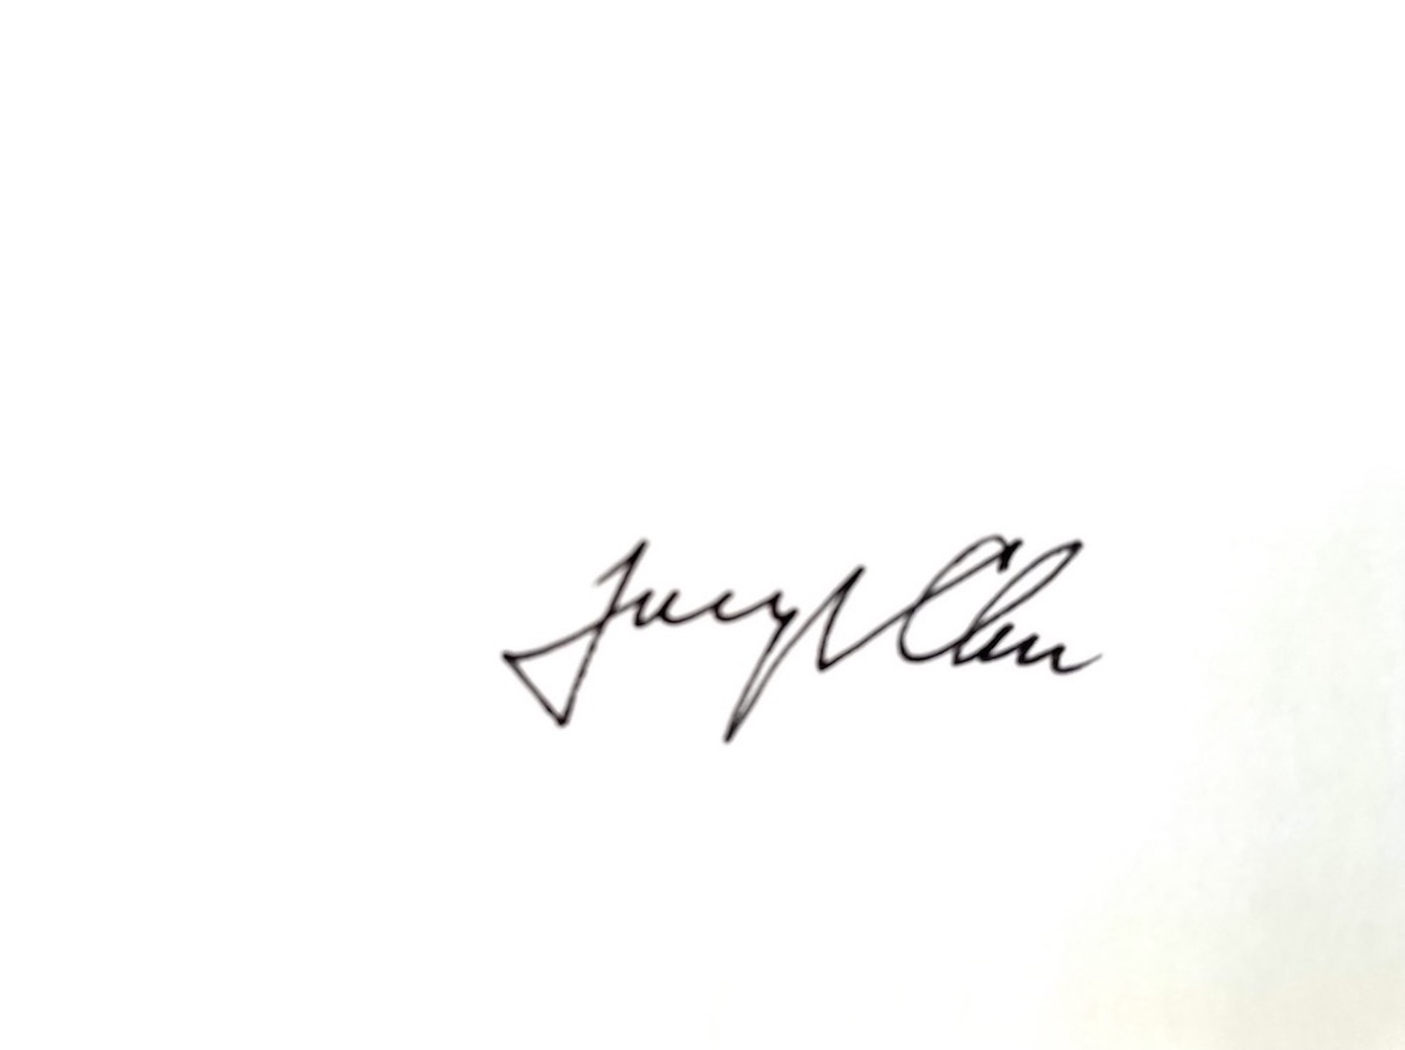
Joseph Y. Chu, MD, FRCPC, FACP, FAHA, FAAN
Assistant Professor of Medicine (Neurology)
University of Toronto
Chair of Research Committee, CCHABA

